Computer Networks Lab - Week 1

PES1201800366

Aditeya Baral

1. Task 1 - Linux Interface Configuration

1.1 Step 1

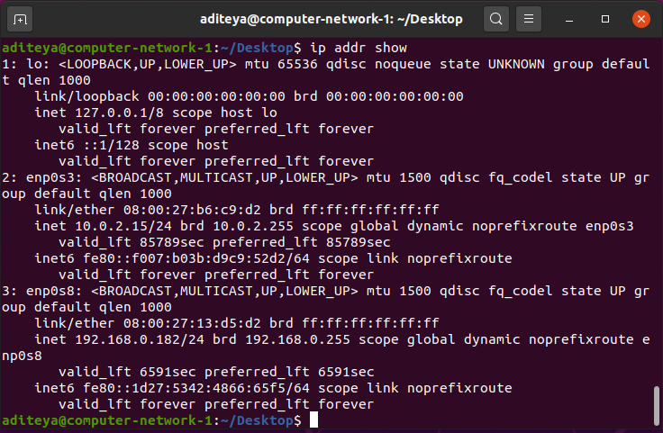

|  |  |  |
| --- | --- | --- |
| **Interface Name** | **IPv4/IPv6** | **MAC Address** |
| lo | 127.0.0.1/::1 | 00:00:00:00:00:00 |
| enp0s3 | 10.0.2.15/fe80::f007:b03b:d9c9:52d2 | 08:00:27:b6:c9:d2 |
| enp0s8 | 192.168.0.182/fe80::1d27:5342:4866:65f5 | 08:00:27:13:d5:d2 |

1.2 Step 2

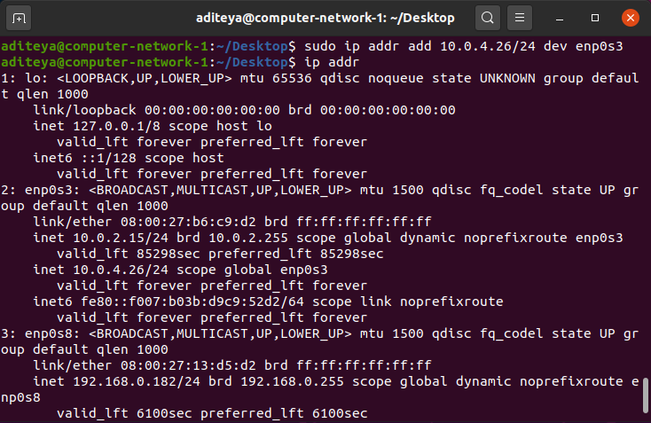

inet 10.0.4.26/24 scope global enp0s3

1.3 Step 3

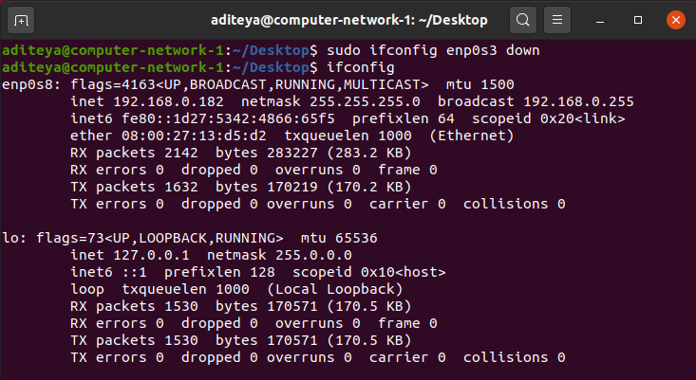

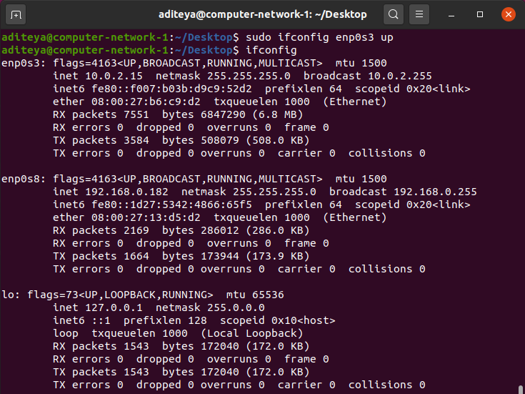

1.4 Step 4

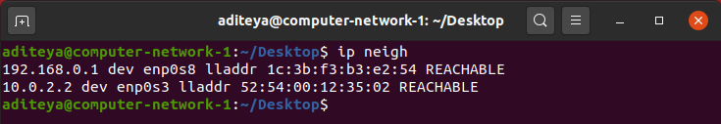

2. Task 2 – Ping PDU (Packet Data Units) Capture

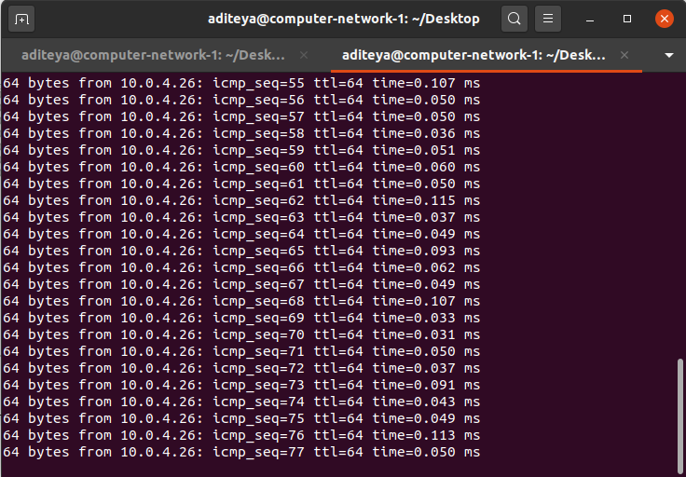

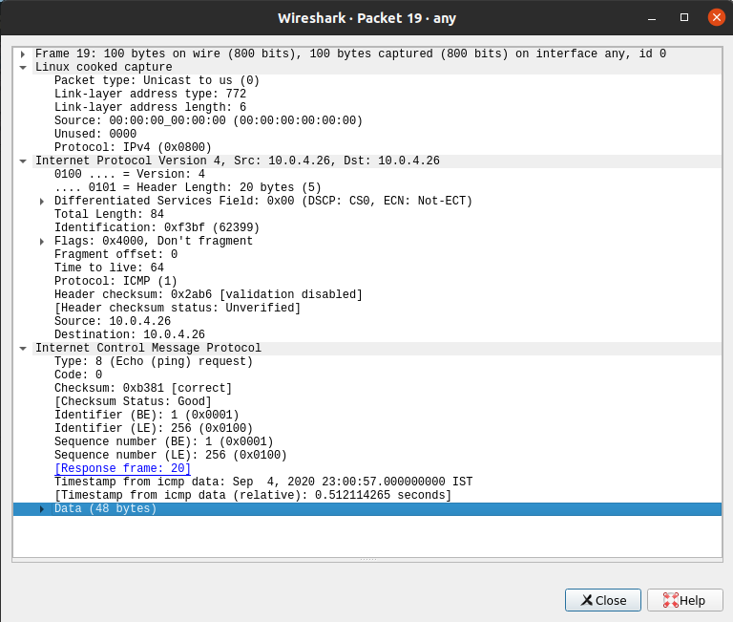

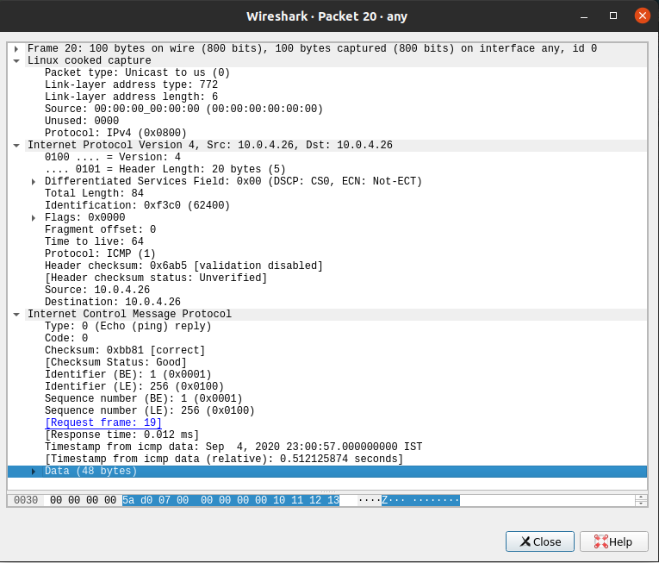

|  |  |  |
| --- | --- | --- |
| **Details** | **First Echo Request** | **First Echo Reply** |
| Frame Number | 19 | 20 |
| Source IP address | 10.0.4.26 | 10.0.4.26 |
| Destination IP address | 10.0.4.26 | 10.0.4.26 |
| ICMP Type Value | 8 | 0 |
| ICMP Code Value | 0 | 0 |
| Source Ethernet Address | 00:00:00:00:00:00 | 00:00:00:00:00:00 |
| Destination Ethernet | 00:00:00:00:00:00 | 00:00:00:00:00:00 |
| Internet Protocol Version | IPv4 | IPv4 |
| Time To Live (TTL) | 64 | 64 |

3. Task 3 – HTTP PDU Capture

3.1 Echo Request and Reply

|  |  |  |
| --- | --- | --- |
| **Details** | **First Echo Request** | **First Echo Reply** |
| Frame Number | 831 | 838 |
| Source Port | 58574 | 80 |
| Destination Port | 80 | 58574 |
| Source IP Address | 10.0.2.15 | 202.83.26.114 |
| Destination IP Address | 202.83.26.114 | 10.0.2.15 |
| Source Ethernet Address | 08:00:27:b6:c9:d2 | 52:54:00:12:35:02 |
| Destination Ethernet Address | 52:54:00:12:35:02 | 08:00:27:b6:c9:d2 |

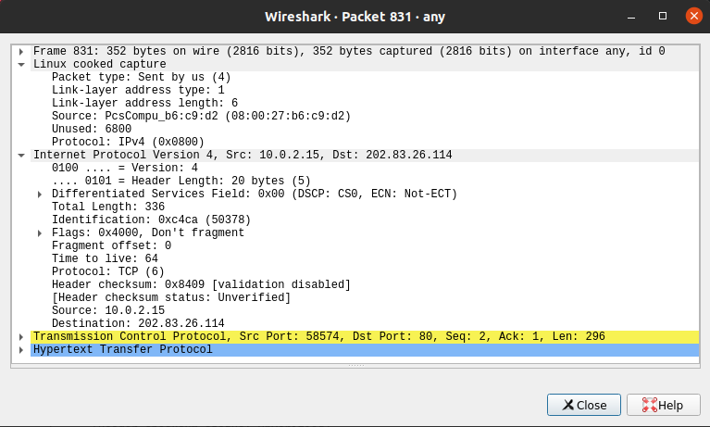

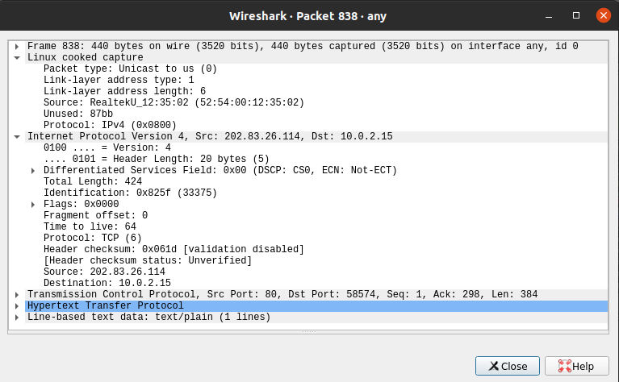

3.2 HTTP Request and Response

|  |  |  |  |
| --- | --- | --- | --- |
| **HTTP Request** |  | **HTTP Response** |  |
| Get | GET /success.txt HTTP/1.1\r\n | Server | AmazonS3 |
| Host | detectportal.firefox.com | Content-Type | text/plain |
| User-Agent | Mozilla/5.0 (X11; Ubuntu; Linux x86_64; rv:80.0) Gecko/20100101 Firefox/80.0 | Date | Fri, 04 Sep 2020 18:17:25 GMT |
| Accept-Language | en-US,en;q=0.5 | Location |  |
| Accept-Encoding | gzip, deflate | Content-Length | 8 |
| Connection | keep-alive | Connection | keep-alive |

3.3 Following TCP Stream

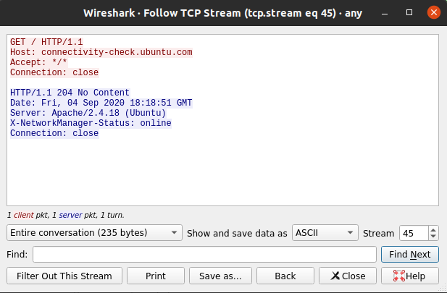

4. Task 4 – Capturing Packets with tcpdump

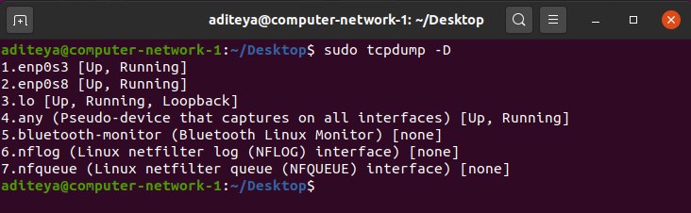

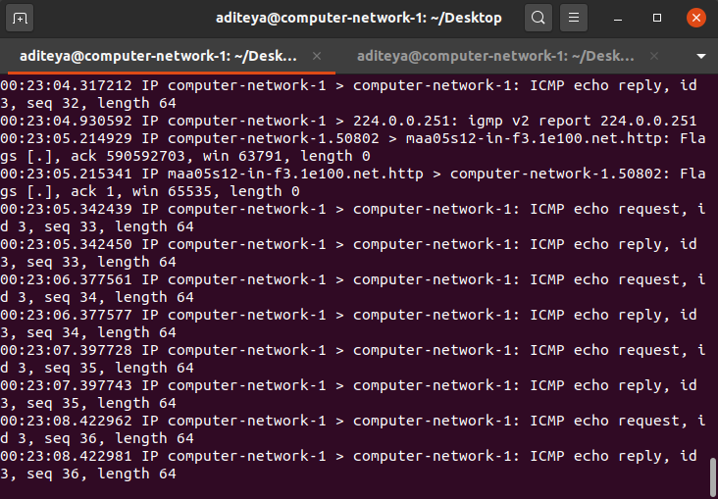

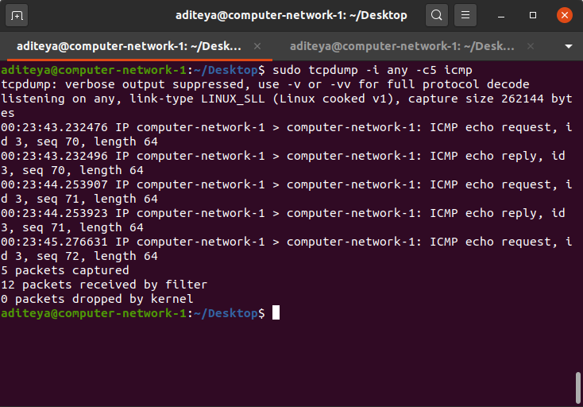

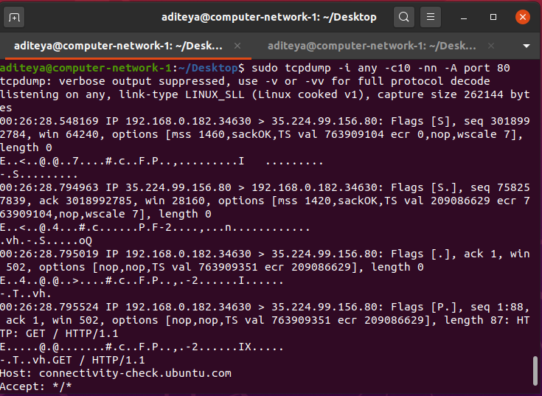

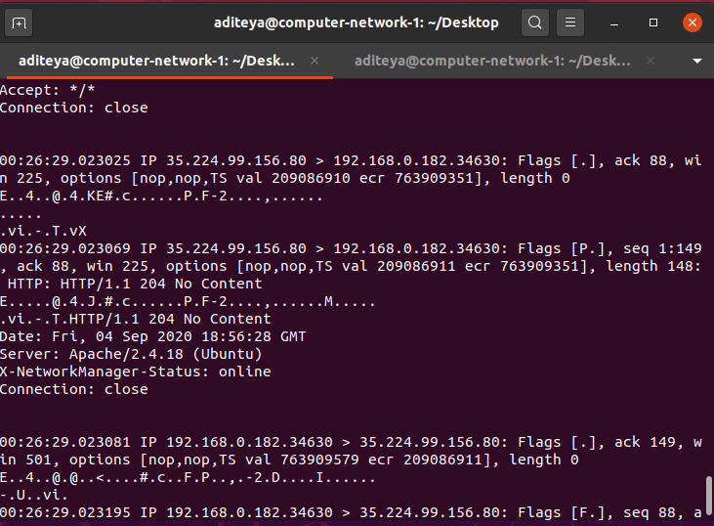

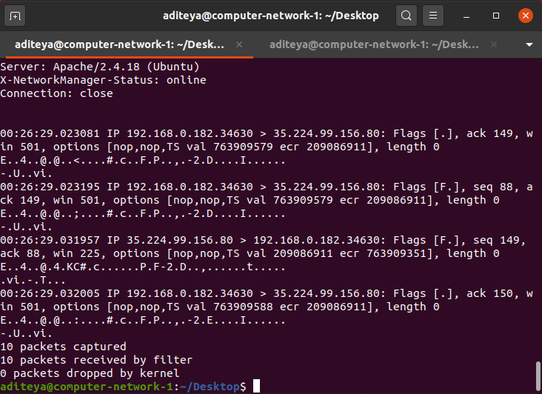

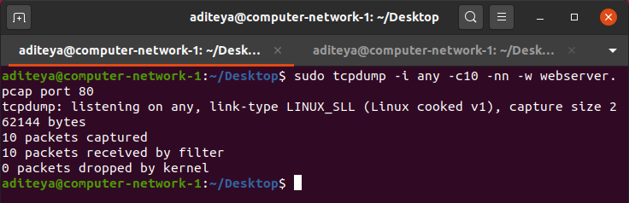

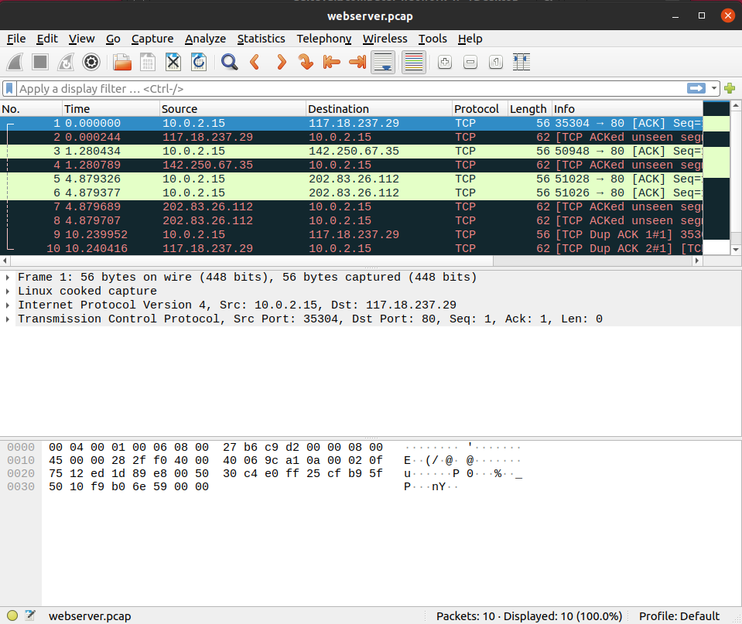

5. Task 5 – Perform Traceroute Checks

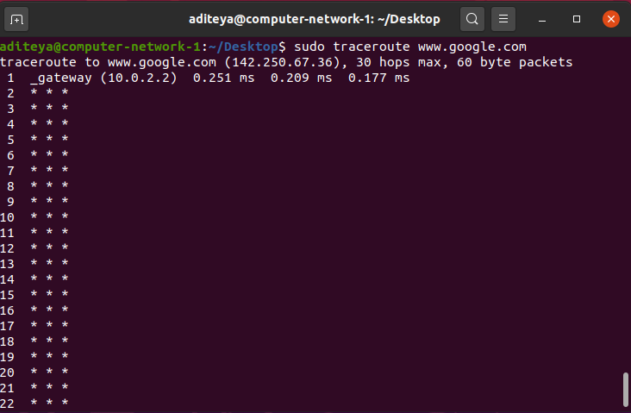

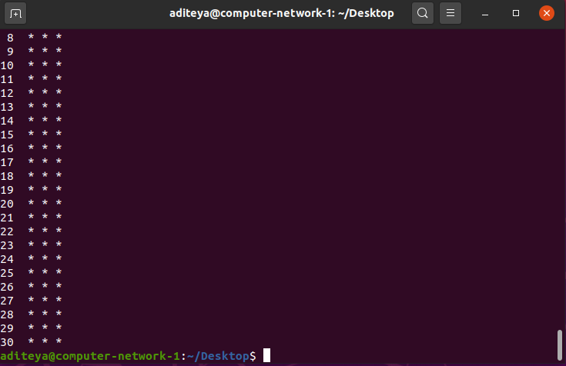

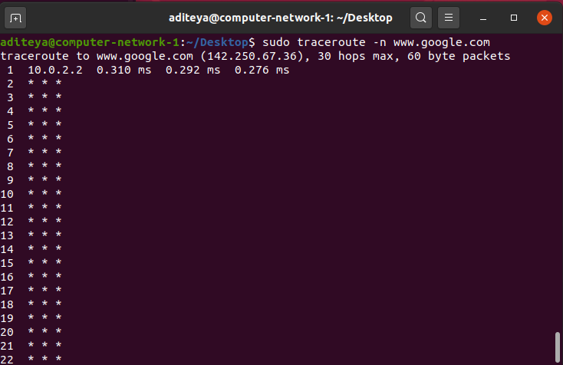

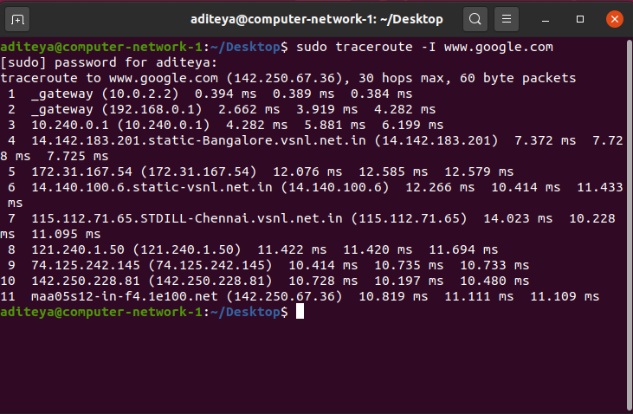

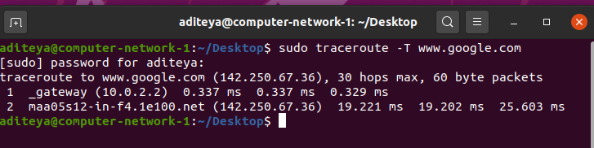

6. Task 6 – NMap

